Quantified Student

Project plan



Created by G. Malisz

Spis treści

1. Version History 2

2. Overview 2

3. Level 1: System Context diagram 2

4. Level 2: Container diagram 3

5. Level 3: Component diagram 4

6. Level 4: UML 5

7. Definitions, Acronyms, and Abbreviations 6

# Version History

|  |  |  |  |
| --- | --- | --- | --- |
| Version | Date | Author | Comment |
| 0.1 | 14-03-2023 | G. Malisz | First iteration of this document, some architecture components will have to be updated |

# Overview

During the stand-ups and meetings of the team, there needed to be more clarity about the

responsibilities of each part of the system. The goal of this document is to create a clear and

concise overview of the Quantified Student system. This document functions as compendium of Quantified Student system, where every part of the system is presented in abstract way with usage of C4 model.

# Level 1: System Context diagram

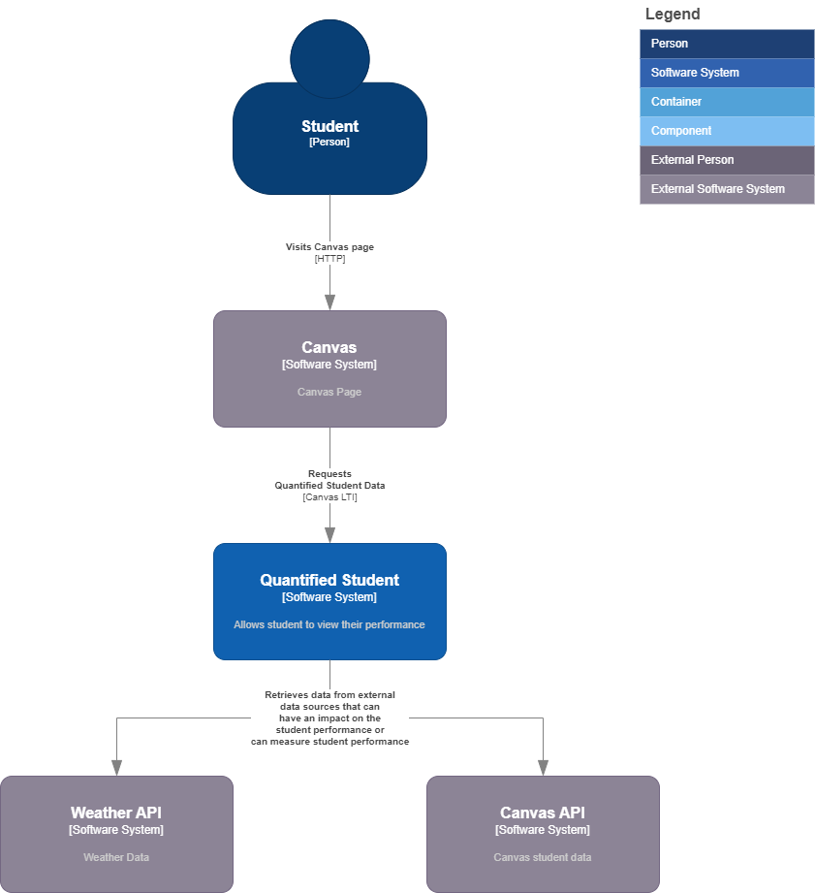

# Level 2: Container diagram

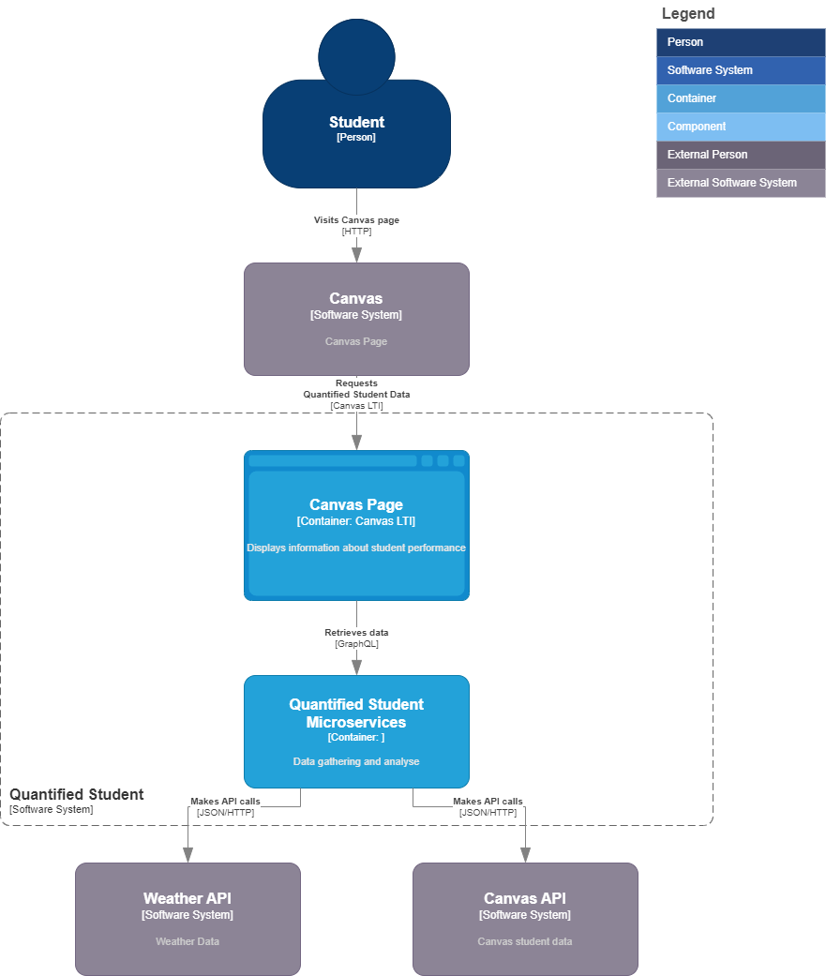

# Level 3: Component diagram

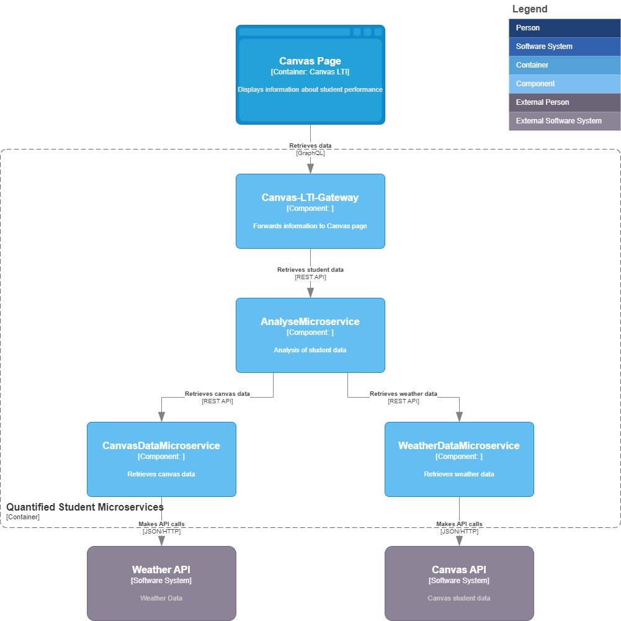

# Level 4: UML

# Definitions, Acronyms, and Abbreviations

|  |  |
| --- | --- |
| Abbreviation | Meaning |
| TBD | To be discussed |
| QS | Quantified Student |
| LTI | The integration technique that we will use to add an application to Canvas |
| DataAnalyseMicroservice | Main part of QS that is gathering and processing data |
| Microservice | Small independent services that communicates with Application |